1. **Histogram for all variables in a dataset mtcars. Write a program to create histograms for all columns.**

**Ans:**

If you combine the tidyr and ggplot2 packages, you can use facet_wrap to make a quick set of histograms of each variable in your data.frame.

You need to reshape your data to long form with tidyr::gather, so you have key and valuecolumns like such:

Using this as our data, we can map value as our x variable, and

use facet_wrap to separate by the key column:

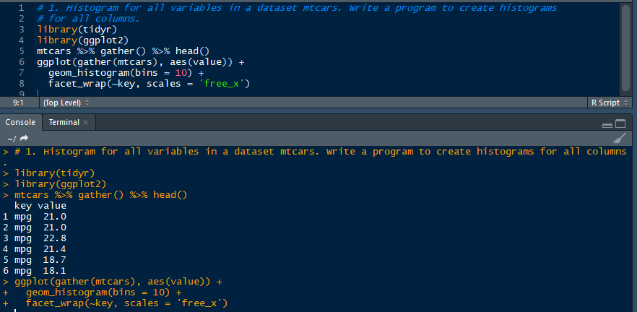

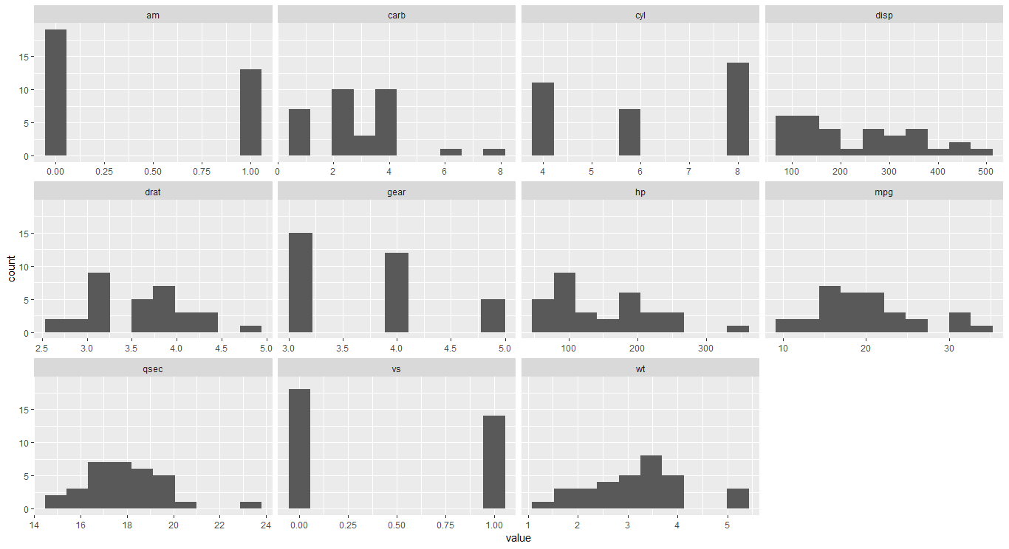

1. **Check the probability distribution of all variables in mtcars.**

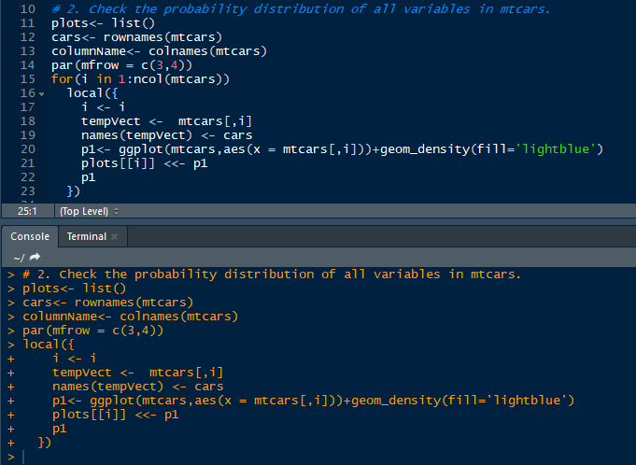

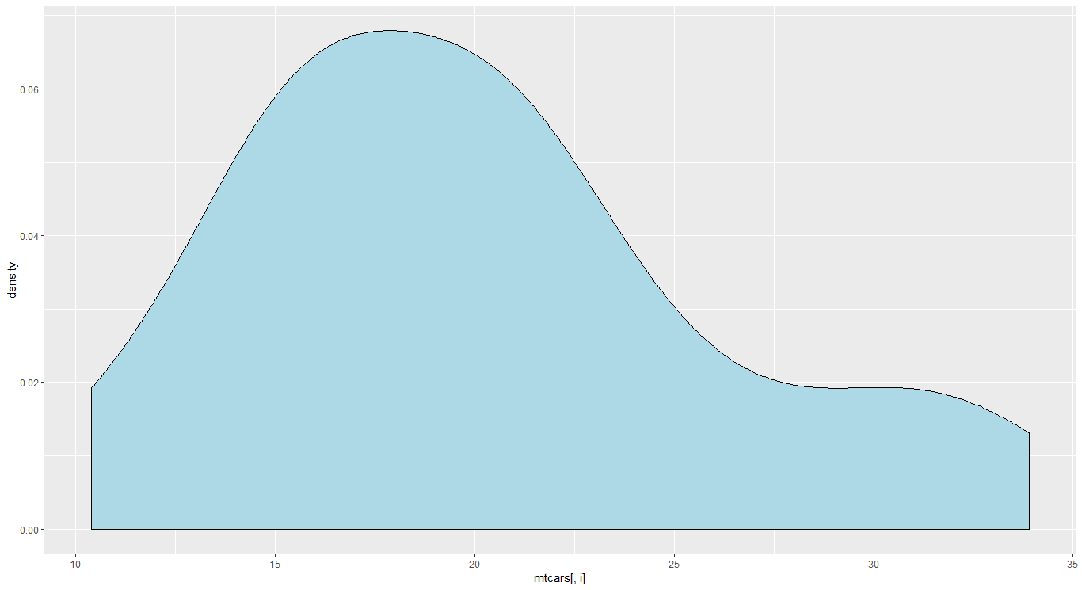

1. **Write a program to create boxplot for all variables.**

boxplot(mtcars$mpg,mtcars$cyl,mtcars$disp,mtcars$hp,mtcars$drat,mtcars$wt,mtcars$qsec,mtcars$vs,mtcars$am,mtcars$gear,mtcars$carb,main = "multiple boxplot",at = c(1,2,3,4,5,6,7,8,9,10,11),names = c("mpg","cyl","disp","hp","drat","wt","qsec","vs","am","gear","carb"),col = heat.colors(5),horizontal = FALSE,notch = TRUE)

